Knowledge Discovery

and

Management

Assignment (LAB-3)

1. **Mashup Application**

The Easy search JSfiddle application done in the lab-2 which had Images, Video, Maps and Animations is now mashed up with weather and twitter.

Lab-2 screen shot

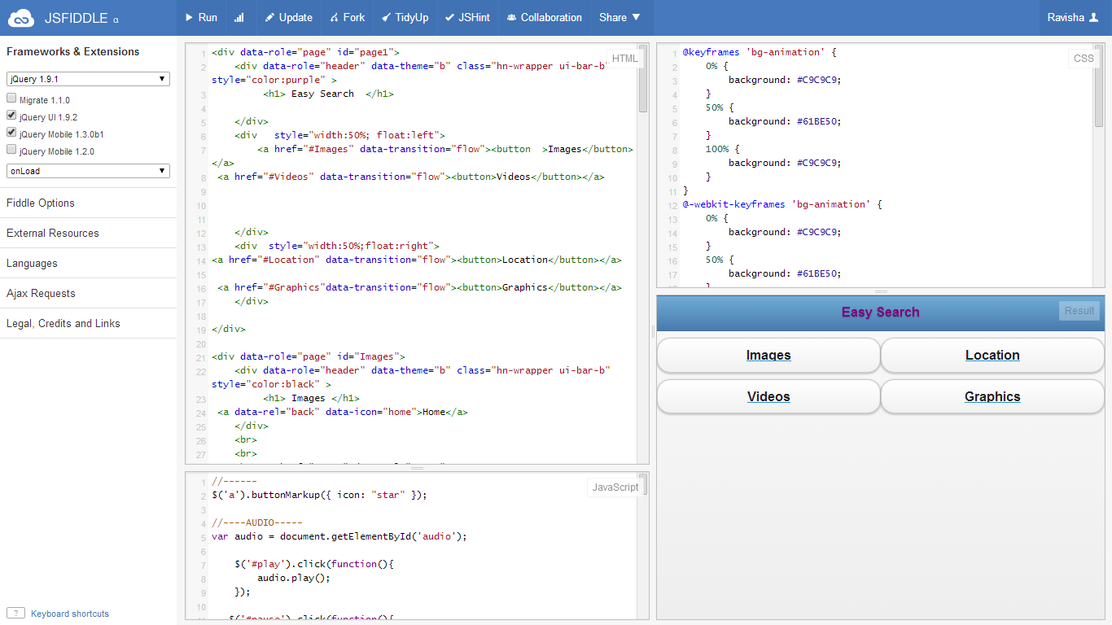

Mashed up JSfiddle application

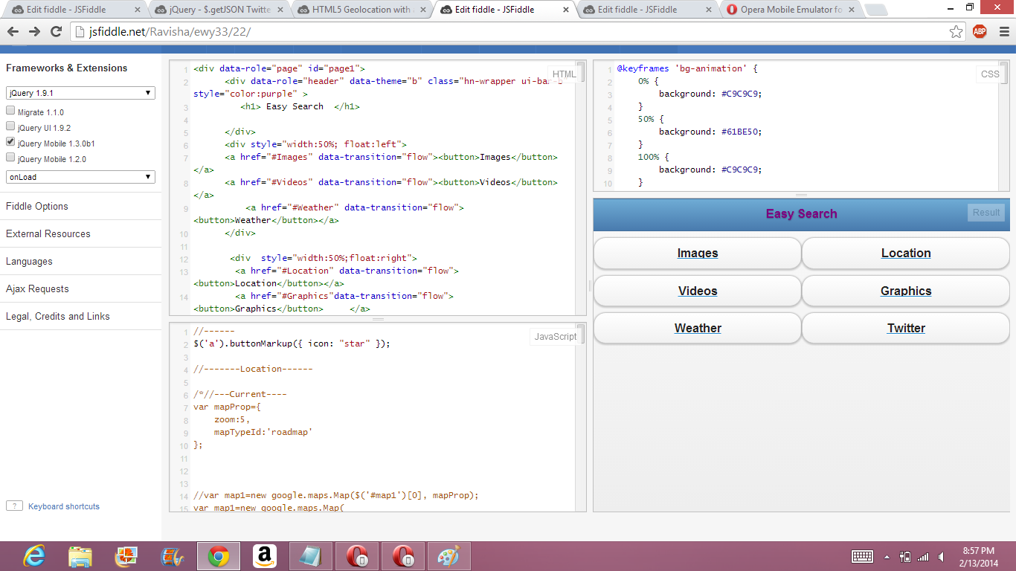

**JSFiddle Mashed Application Screenshots in Opera Emulator**

I have downloaded the opera emulator and deployed the created jsfiddle application in it. Here are the screen shots of the JSfiddle Application in Emulator.

Home Page in Easy Search

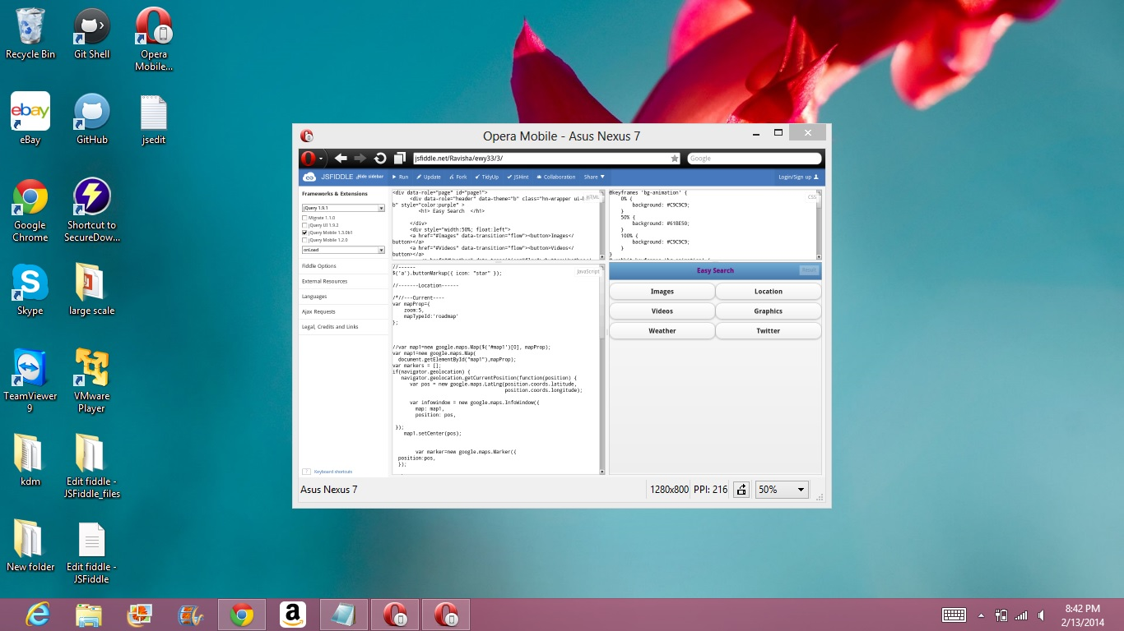

**Images page**

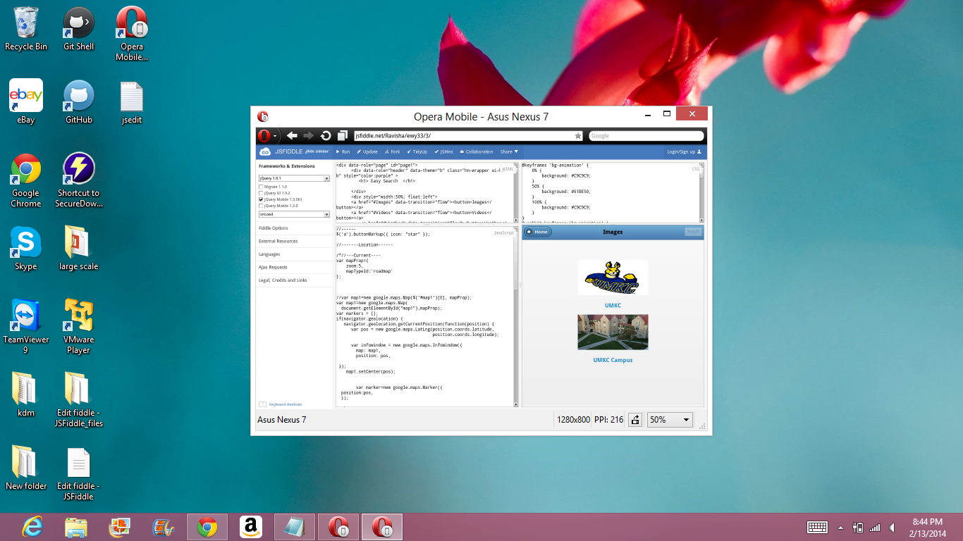

**Location Page**

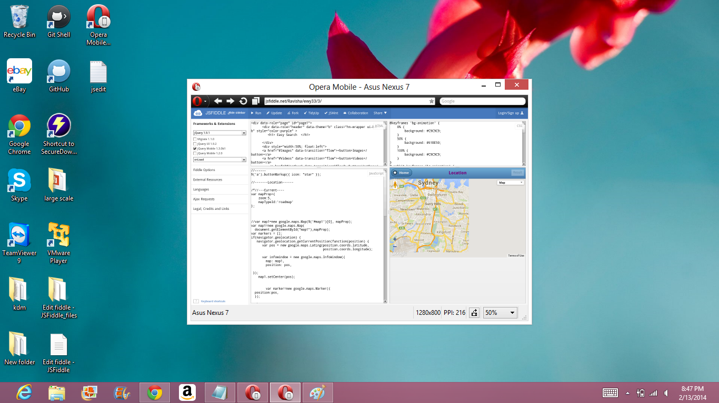

**Animation Page**

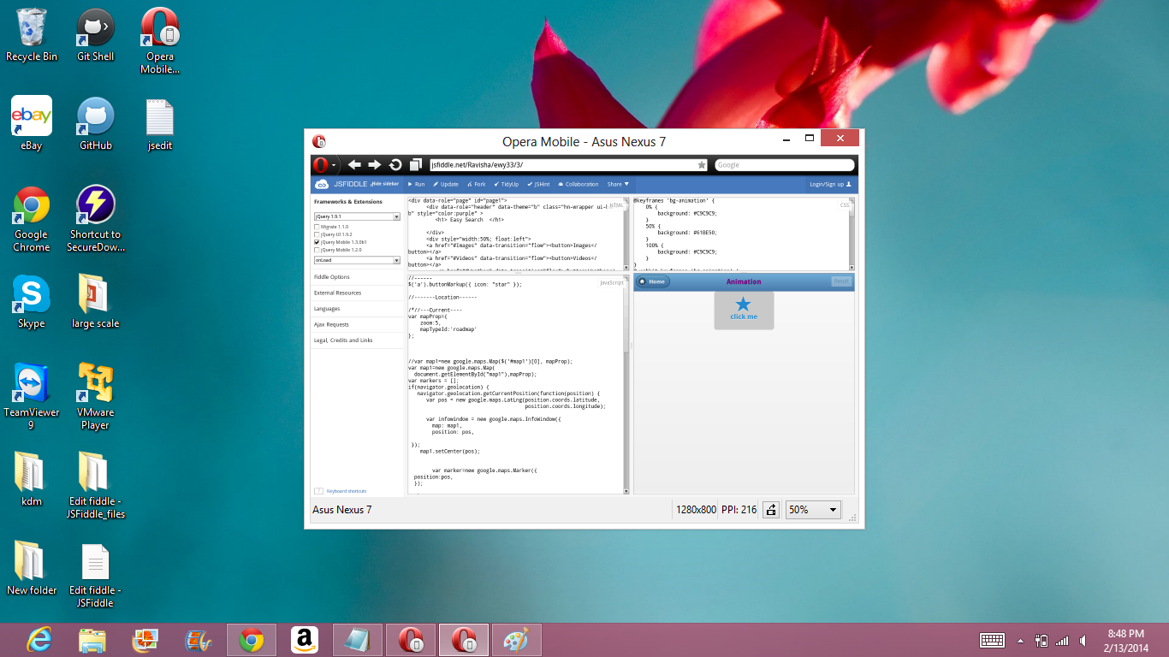

**Videos Page**

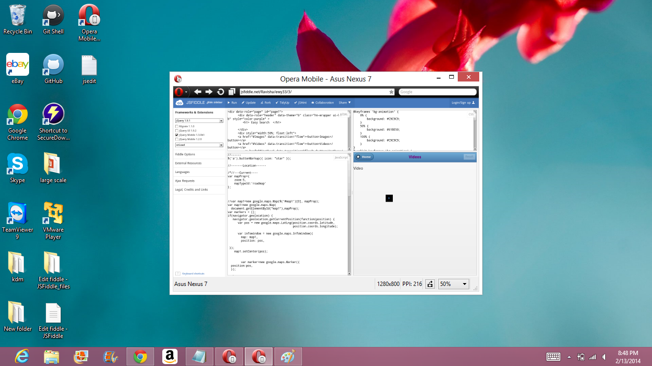

**Twitter Page**

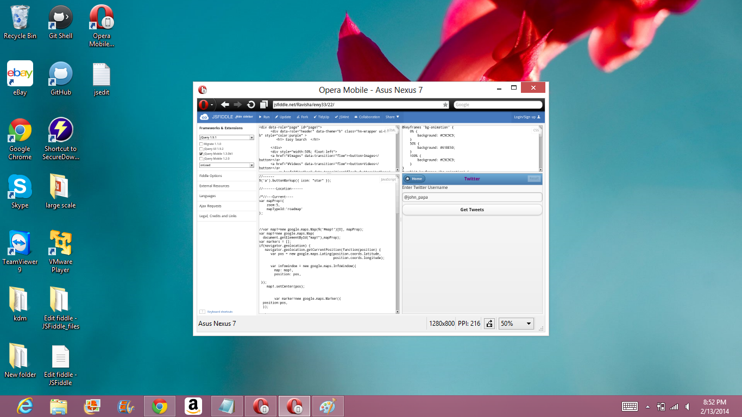

1. **Succesfull Installation of Cloudera**



**Wordcount Implementation**

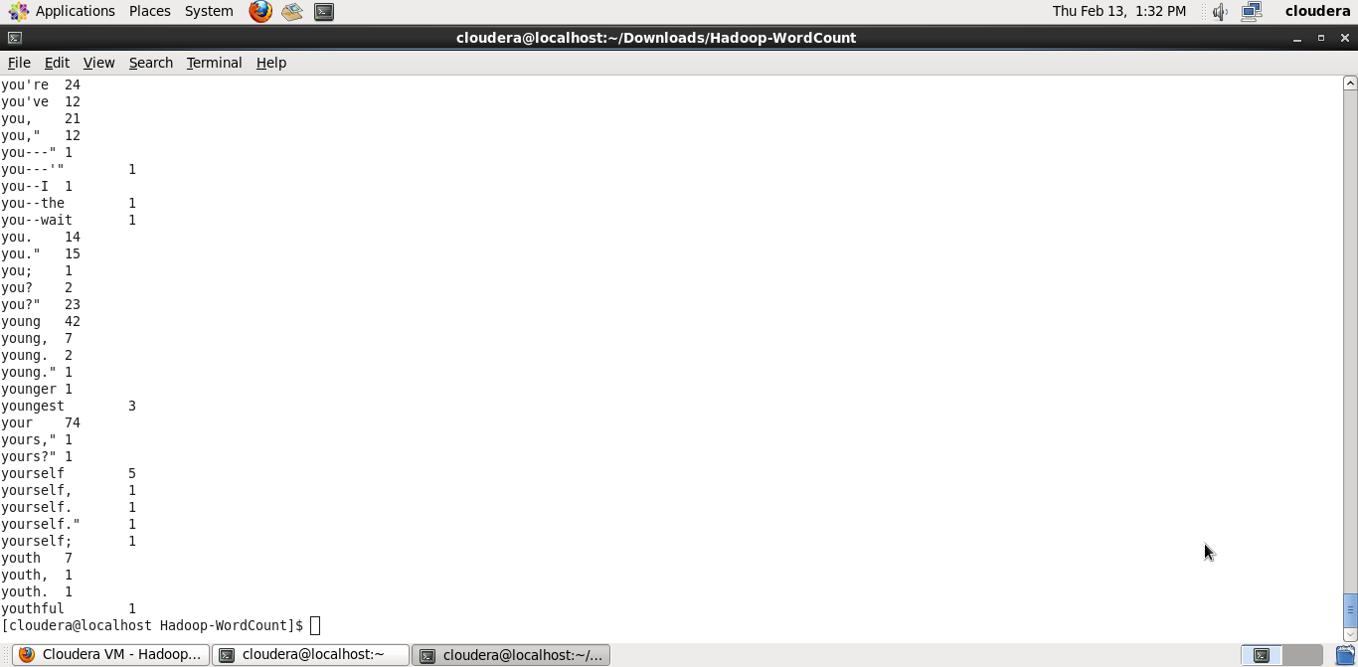

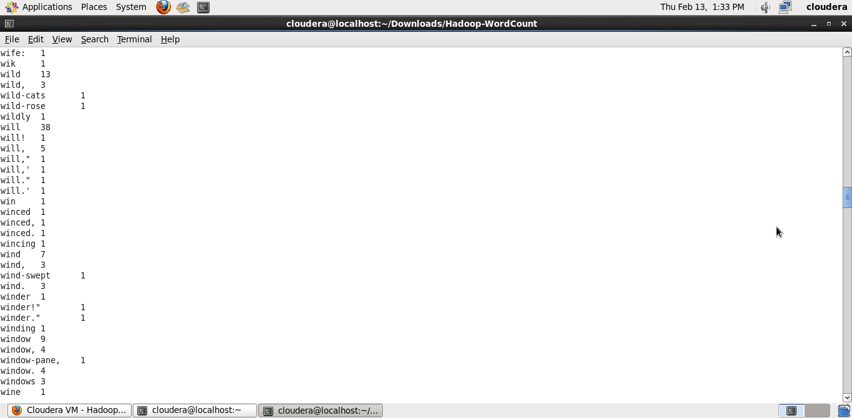

1. **Successful Installation and Version of Mahout**

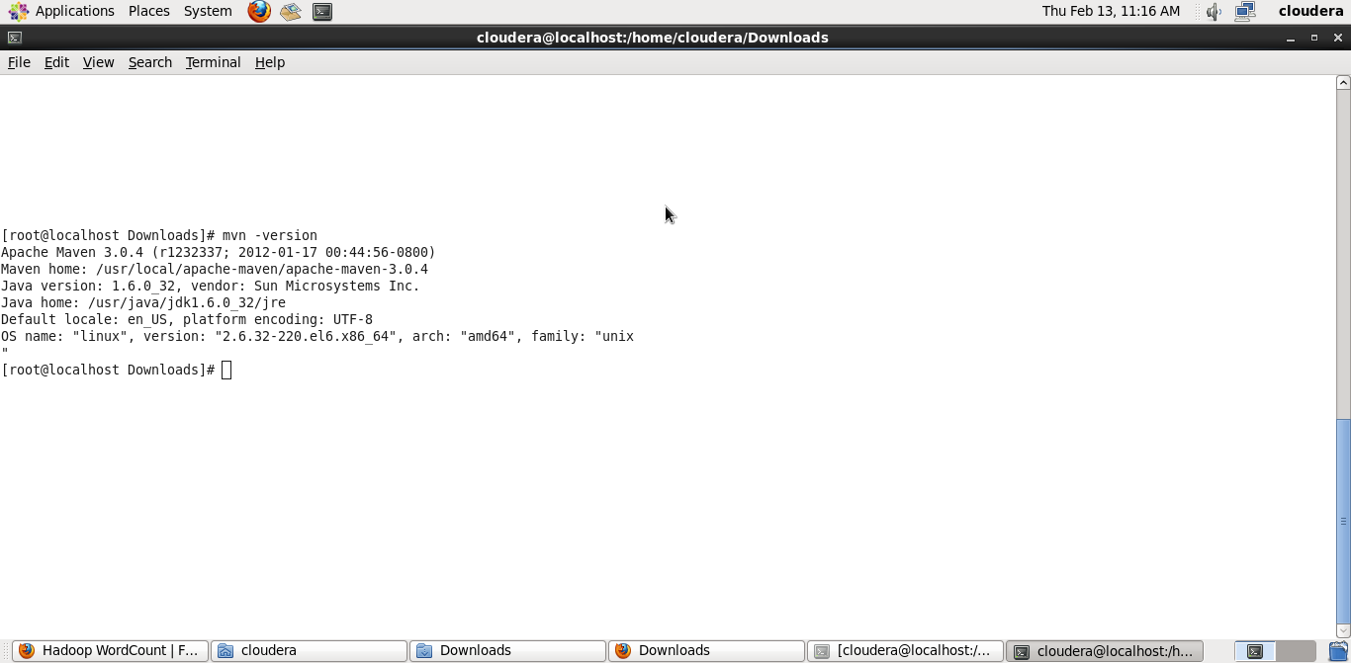

**Naive Bayes Implementation- Confusion Matrix**

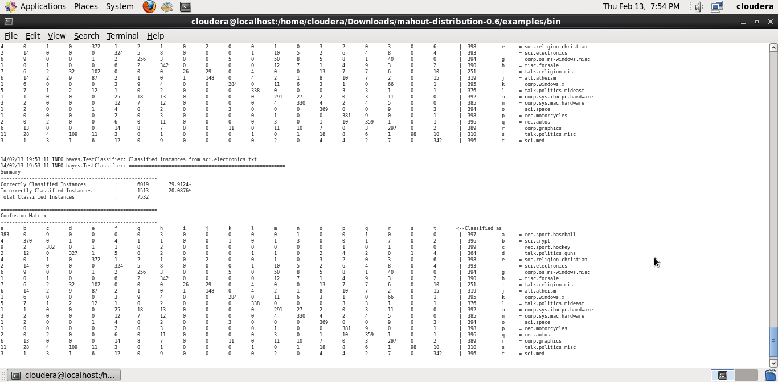

**SGD Confusion Matrix**

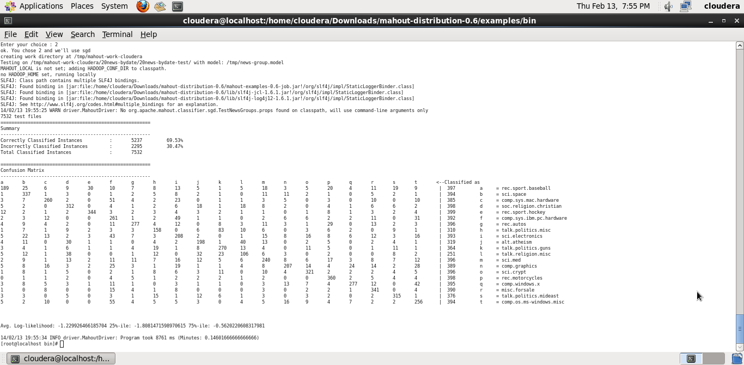

**References**

<http://demos.jquerymobile.com/1.1.2/docs/buttons/buttons-icons.html>

[w3schools.com](http://w3schools.com/)

<https://www.google.com/search?q=images&source=lnms&tbm=isch&sa=X&ei=mt3xUsjcC8jQ2AXOmYDgAQ&sqi=2&ved=0CAcQ_AUoAQ&biw=1366&bih=664#q=umkc&tbm=isch&facrc=0%3Bumkc%20logo&imgdii=_&imgrc=_>

<http://jsfiddle.net/jEhJ3/597/>

<http://jsfiddle.net/krasimir/fQqqY/2/>

<http://jsfiddle.net/johnpapa/YS3u4/light/>